|  |  |  |
| --- | --- | --- |
| **NAME** | **:** | **MUCHAMMAD NABIL HAYKAL WIDARTO** |
| **CLASS** | **:** | **SIB-1G** |
| **NIM** | **:** | **2341760152** |

**JOBSHEET 9**

**https://github.com/muchnabil/daspro-jobsheet9**

**EXPERIMENT**

1. 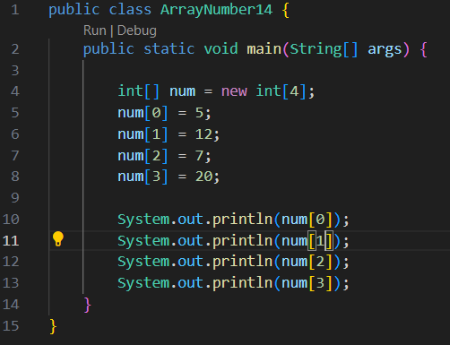

2. 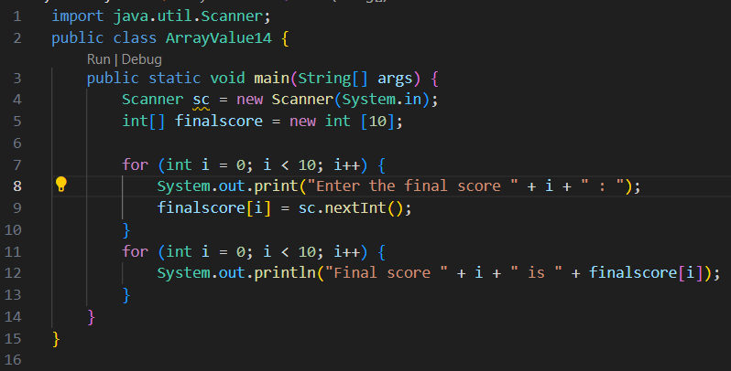

3. 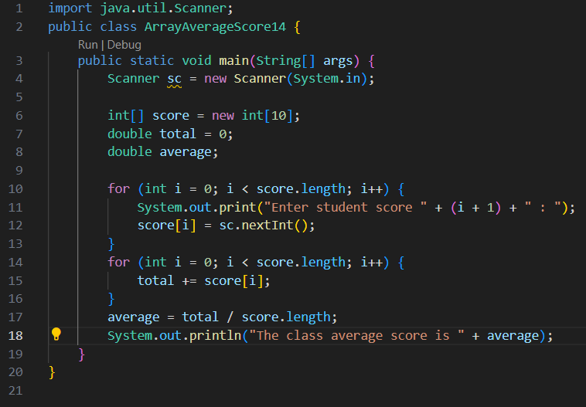

4. 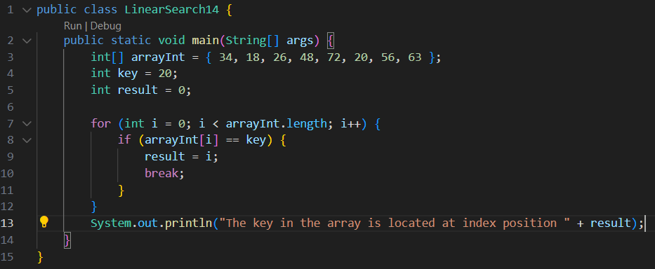

QUESTION 2.1

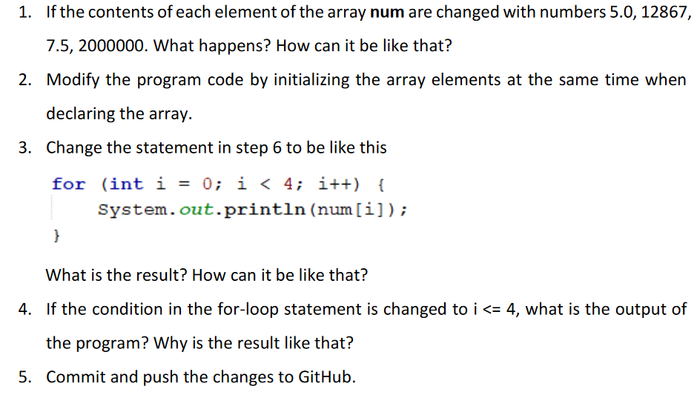

**ANSWER**

1. Error because the data type used is int[], while the value to be entered must use the double[] data type.

3. 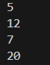 the result is the same, but the process is different, this process uses looping to make the program shorter

4. 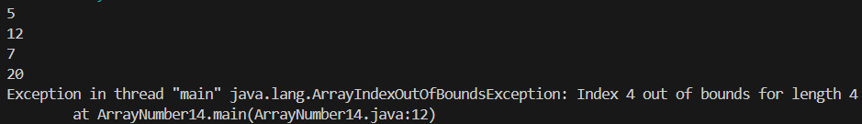

error results because the declared limit is only 4.

**QUESTION 2.2**

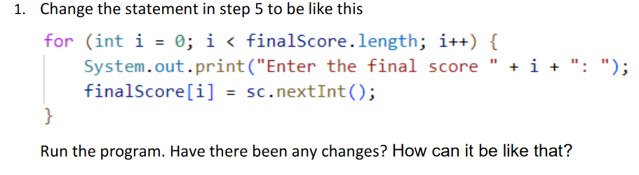

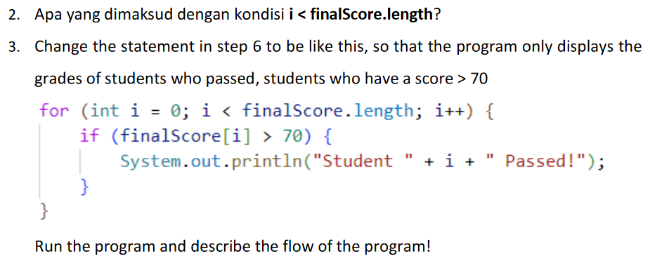

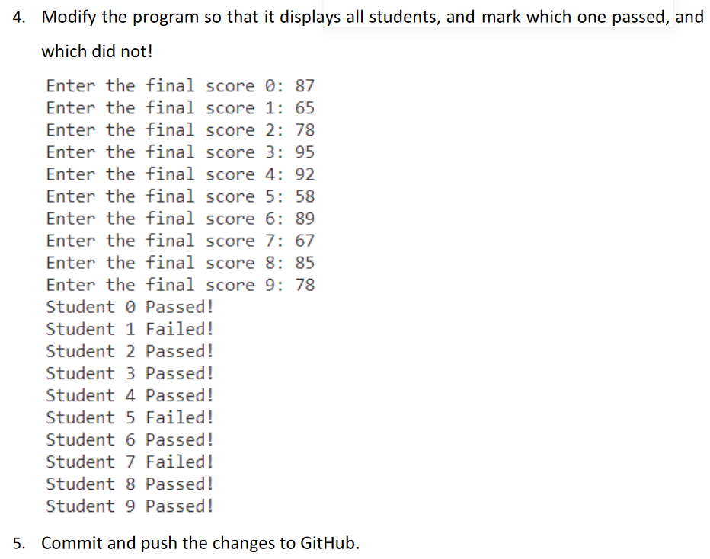

**ANSWER**

1. 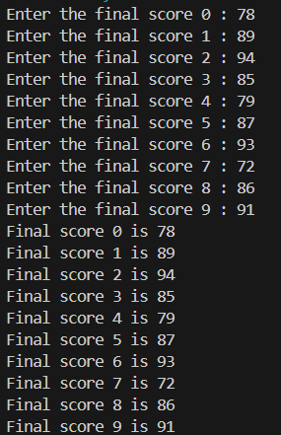

The results are the same but the method is shorter and easier to understand.

2. *finalScore.length* is a property in Java that gives the length (number of elements) of the finalScore array. So, if finalScore contains 5 elements, *finalScore.length* will be 5

3. 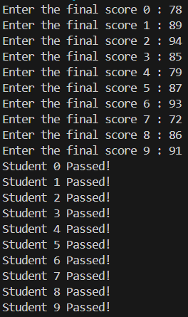 The final score of all grades is declared passed because the passing limit is > 70

4. 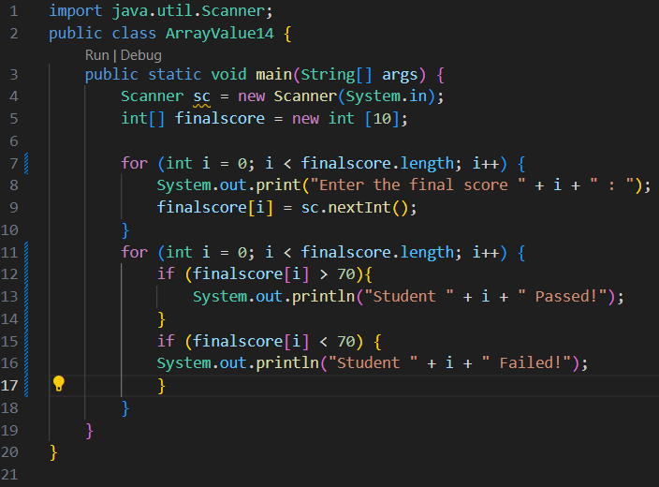

**QUESTION 2.3**

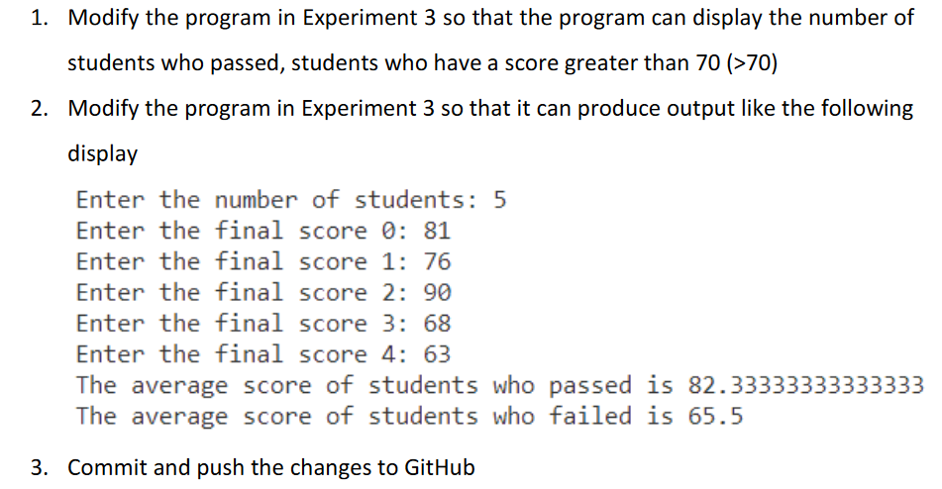

**ANSWER**

1.